First we assign some constants 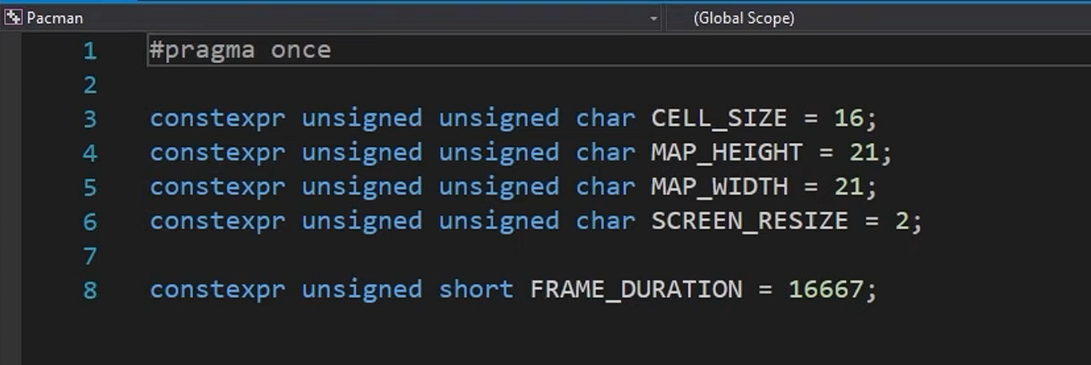

And then we create a window

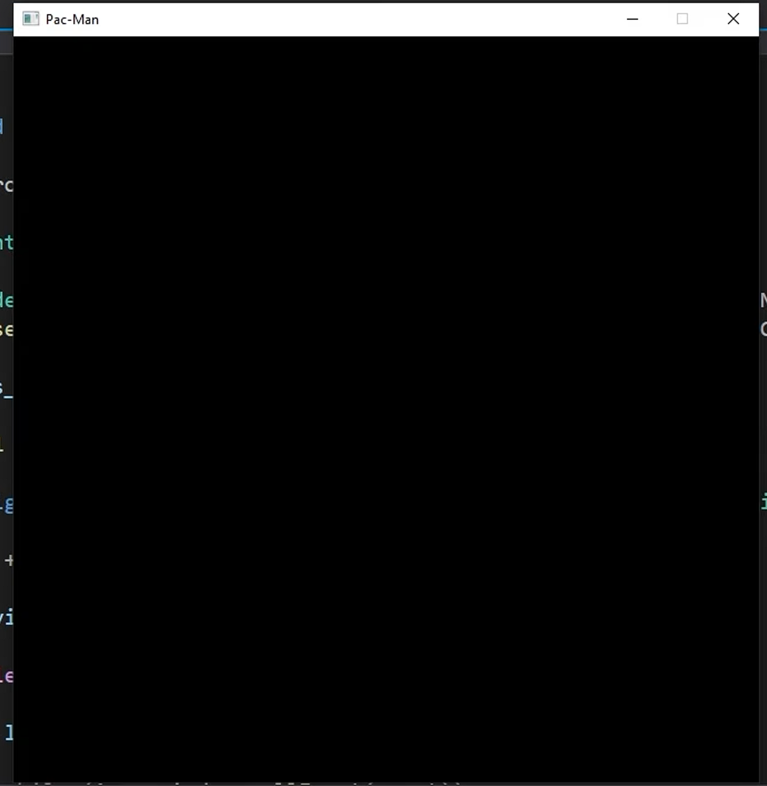

Which was not hard

Since pac man has a specific map so we have to store it in that particular code using array or vector

Vector 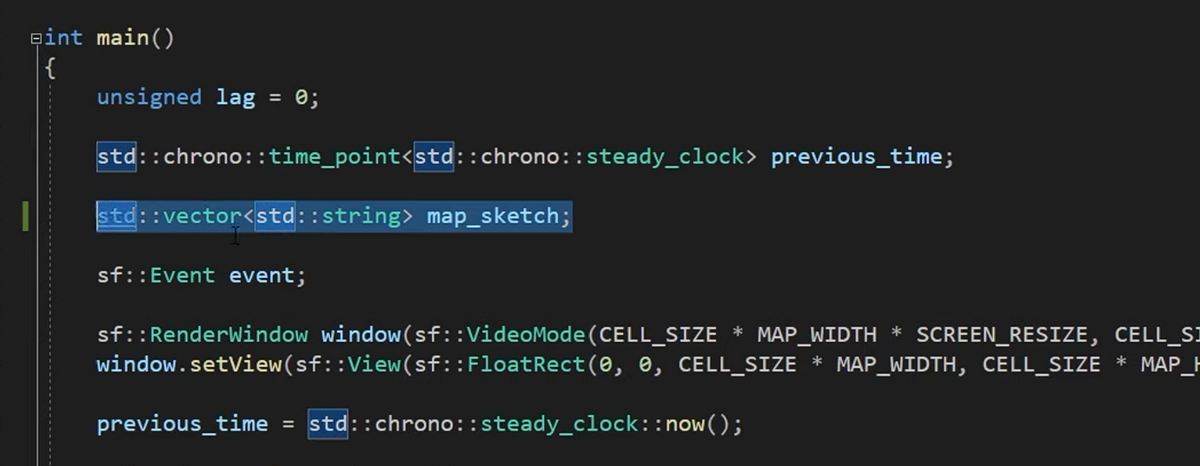

ARRAY

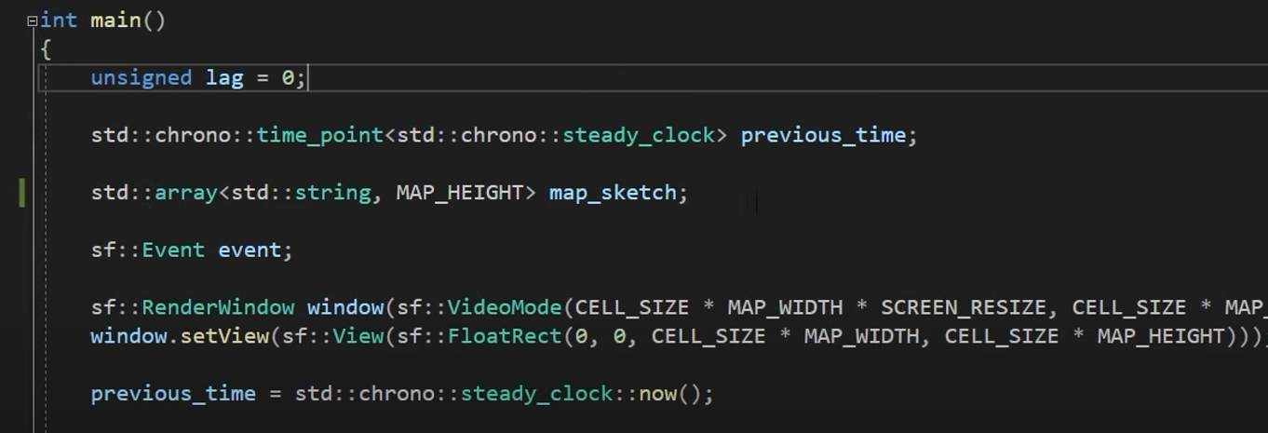

Our goal was to turn the below in to a map

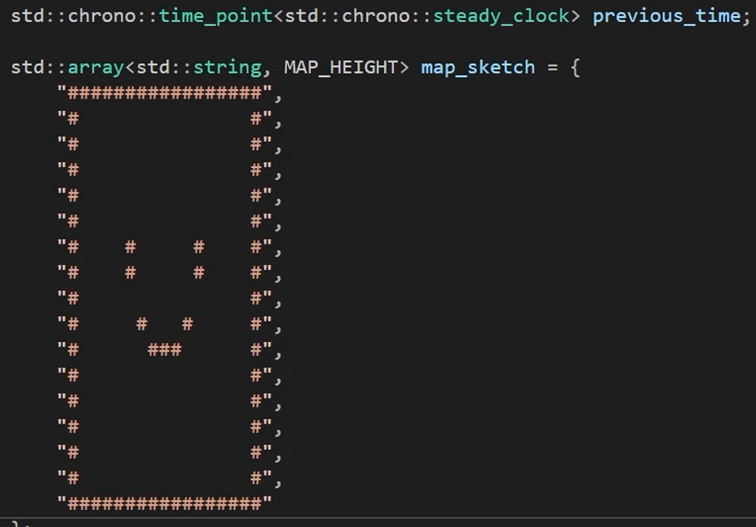

And then we wrote a function which will look through our sketch and turn each character into a cell

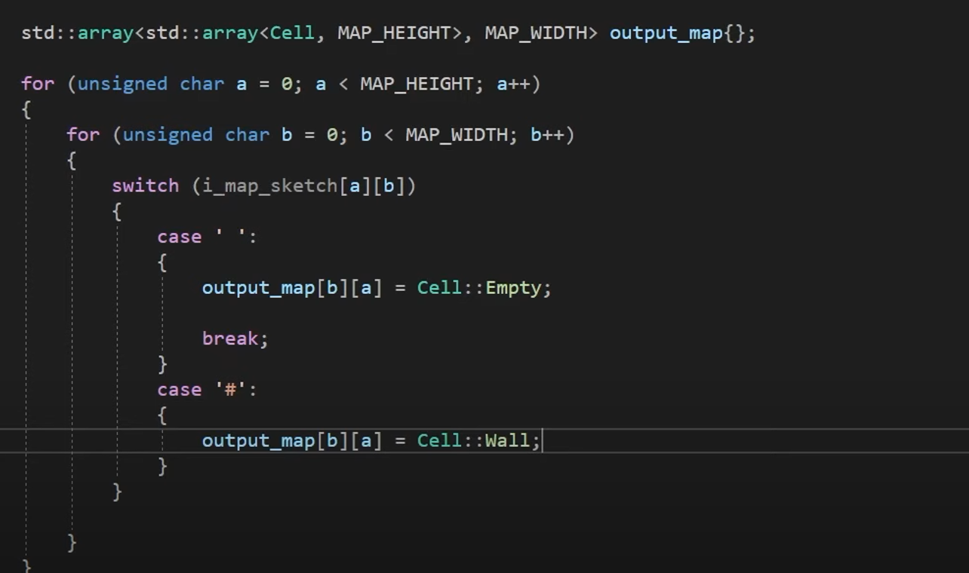

And another function to draw the map itself

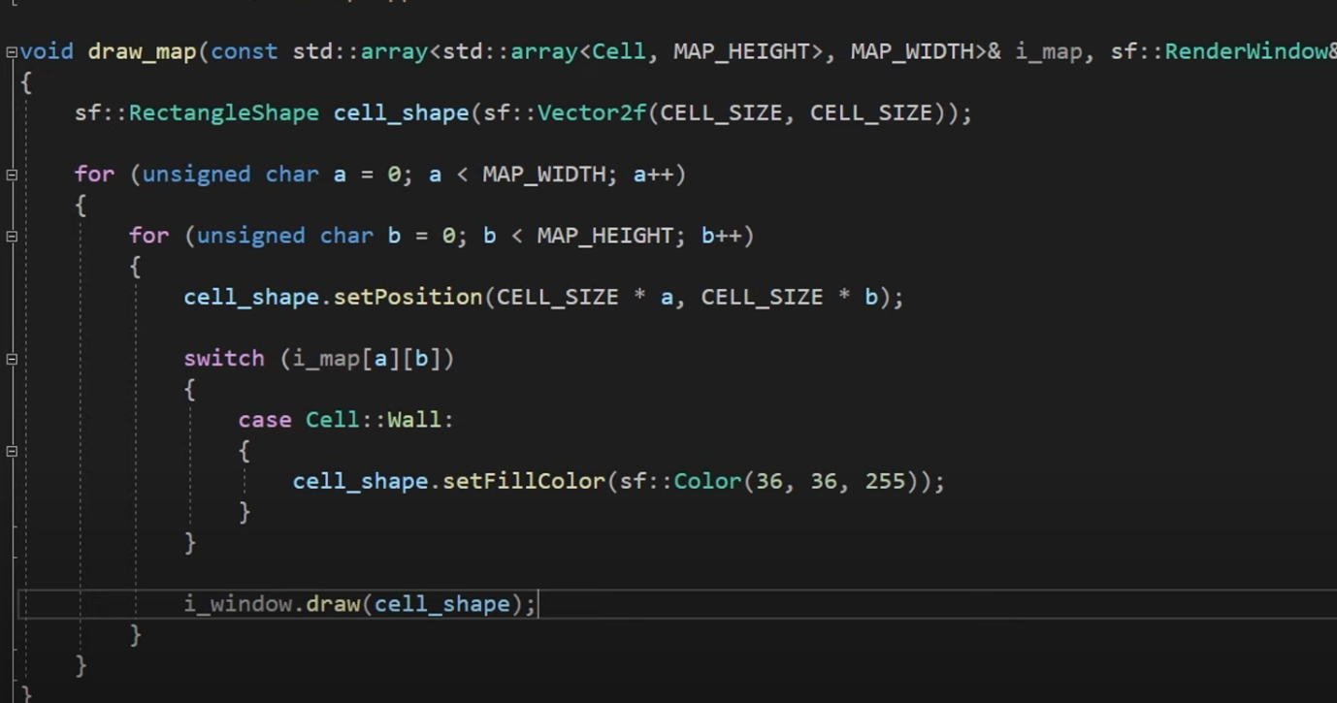

And tried running it

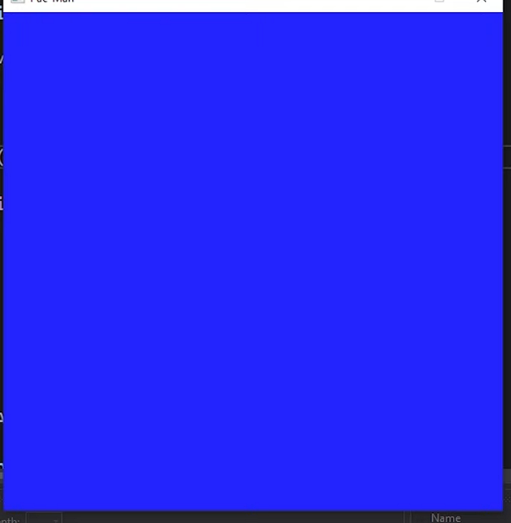

It did not look like we expected

After that we make some adjustments to the code then it was running properly

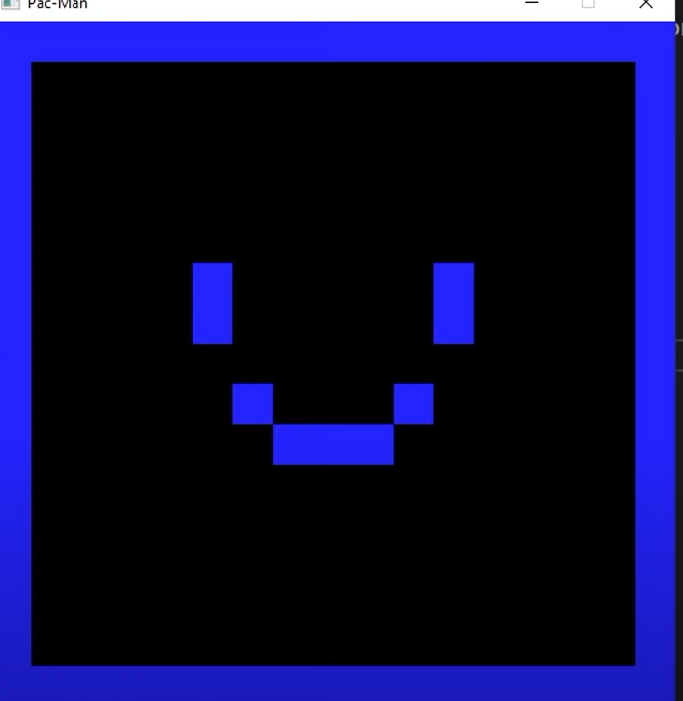

Now its time to make pac man

We made a class for pacman called pacman

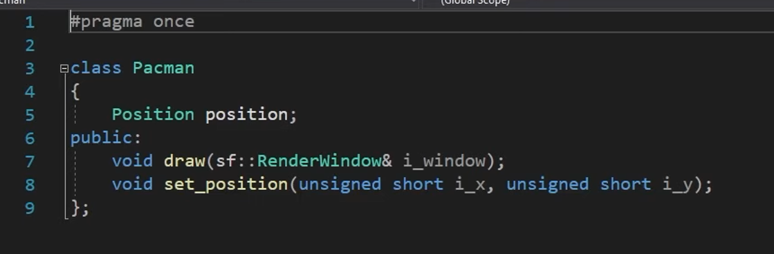

We worry about the graphics later and simply draw a yellow circle

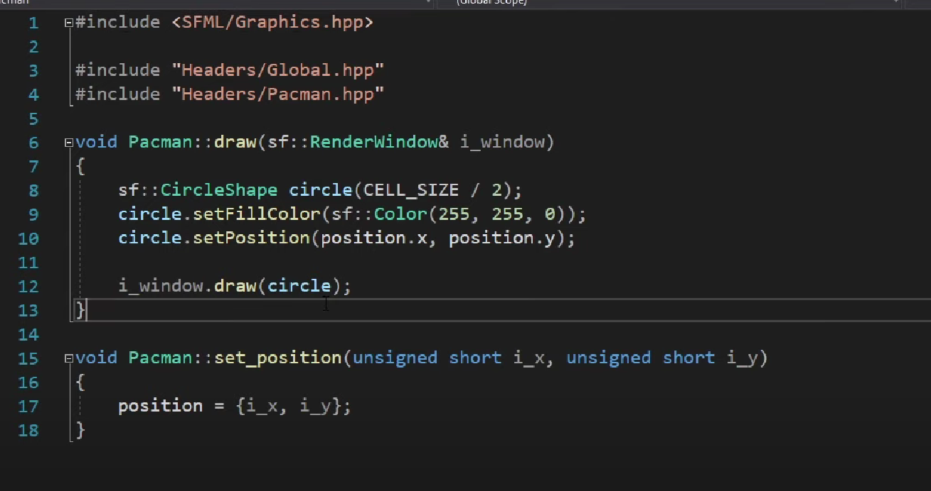

And the sketch function will position it based on the sketch

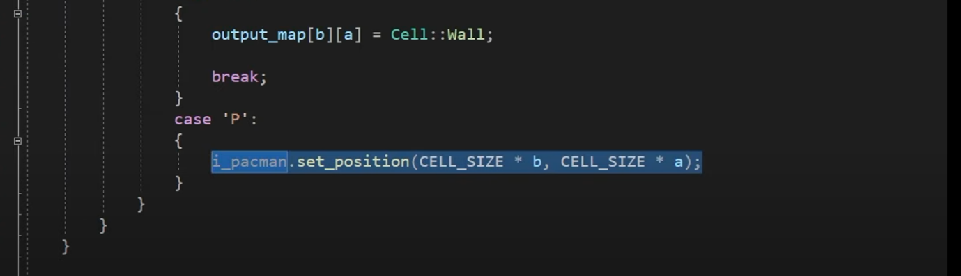

And the output was

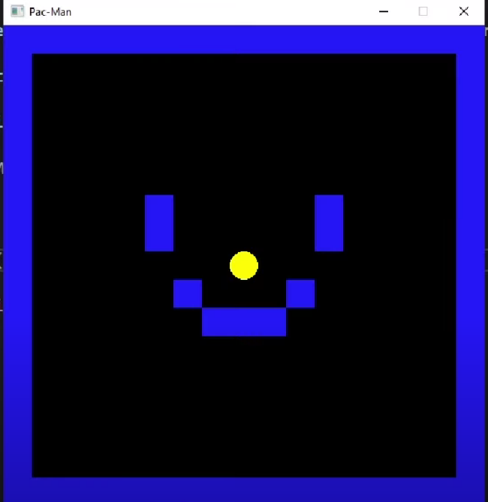

Now will get him move

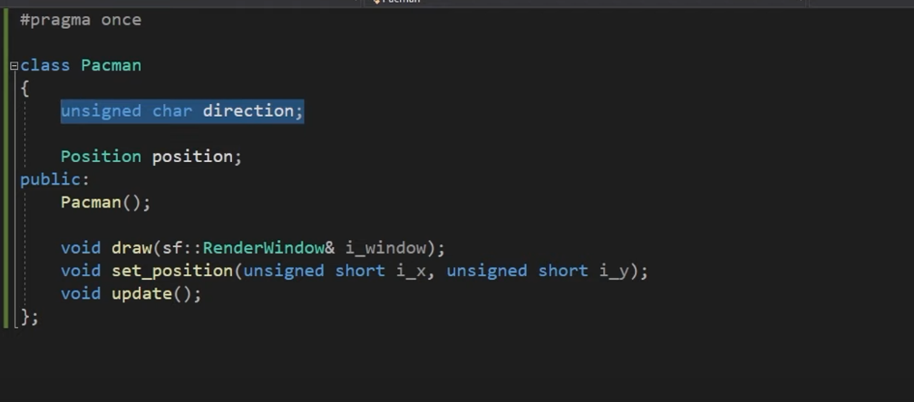

And move pacman the a dirction in each frame

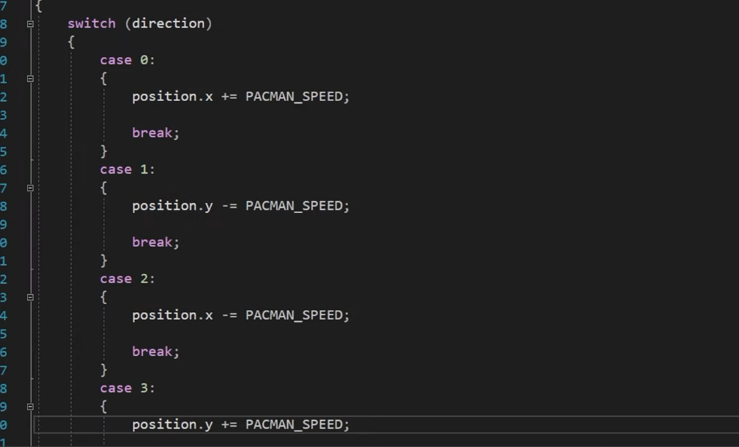

And sorted some of my errors after changes

The output was that yellow ball was moving on the screen on the right side

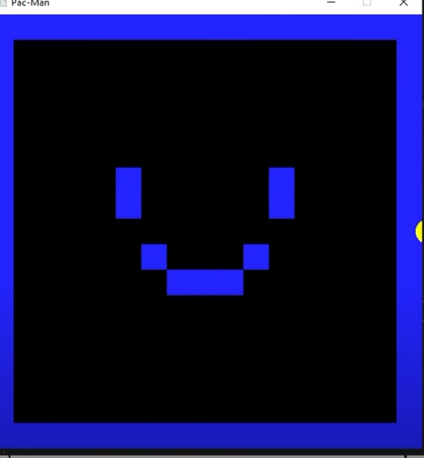

Now we will add controls to control it

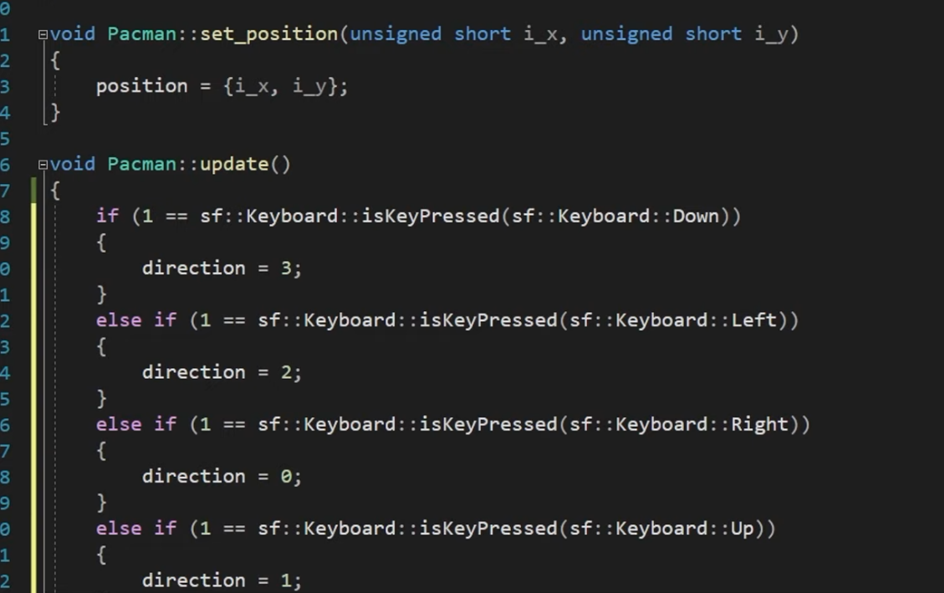

And the output was that I was able to move it

With the keys I was I able to control it

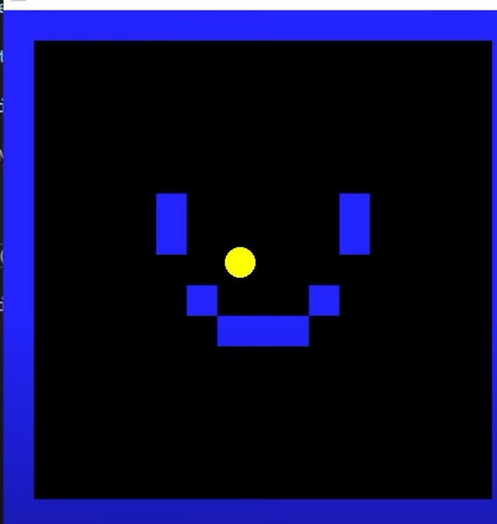

After this we added collision checking whether or not wall are there

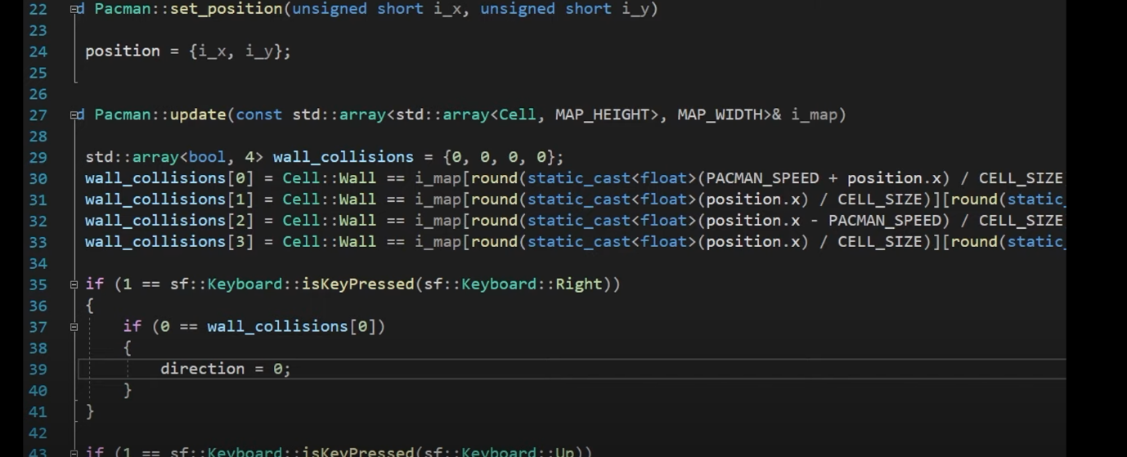

But we failed to get it correct for some time and gave up the idea

And thought of another which was

That in the first idea was that we were using grind to stop pacman but the new idea is to check the in which block pacman is intersecting

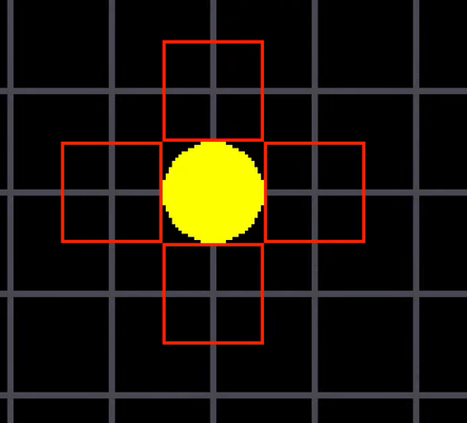 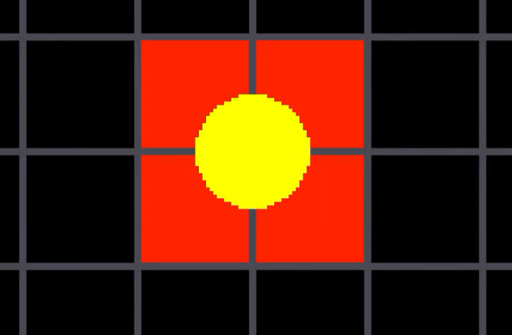

Now the function will look like this

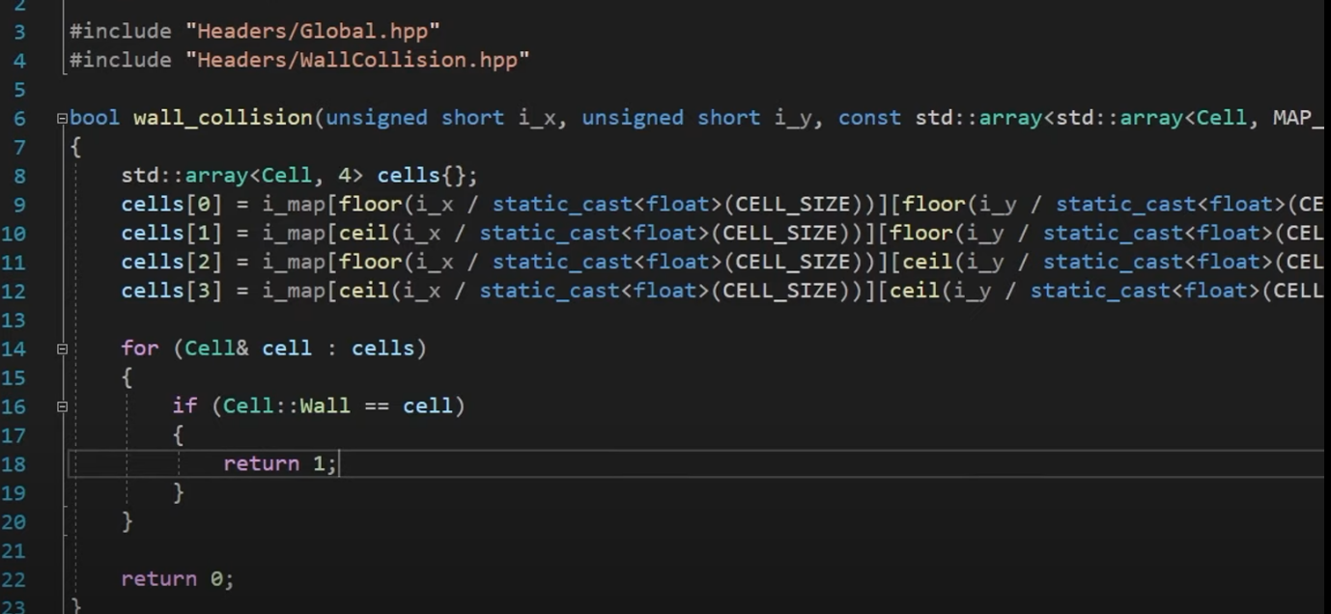

And the output was that pacman was able to collide with the wall

And now that we done with collision cheching we can change the map in to collision map

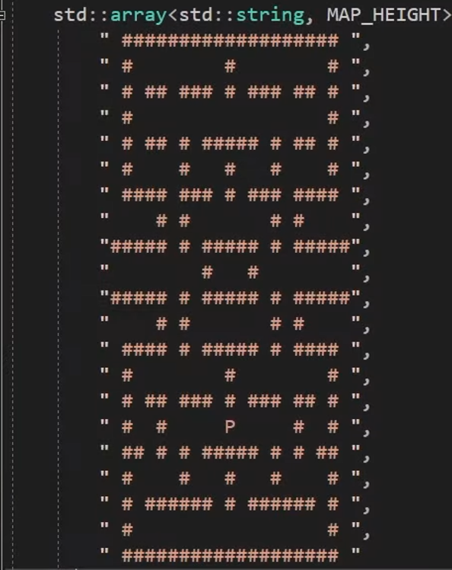

Out put

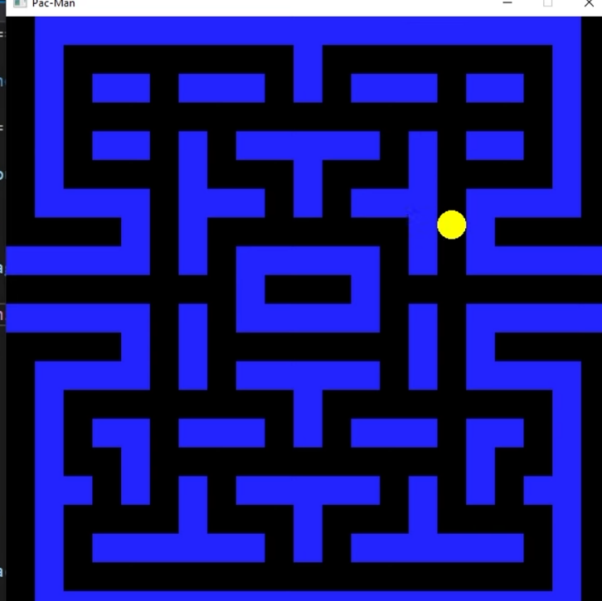

As you can see that we have two tunnels in the map

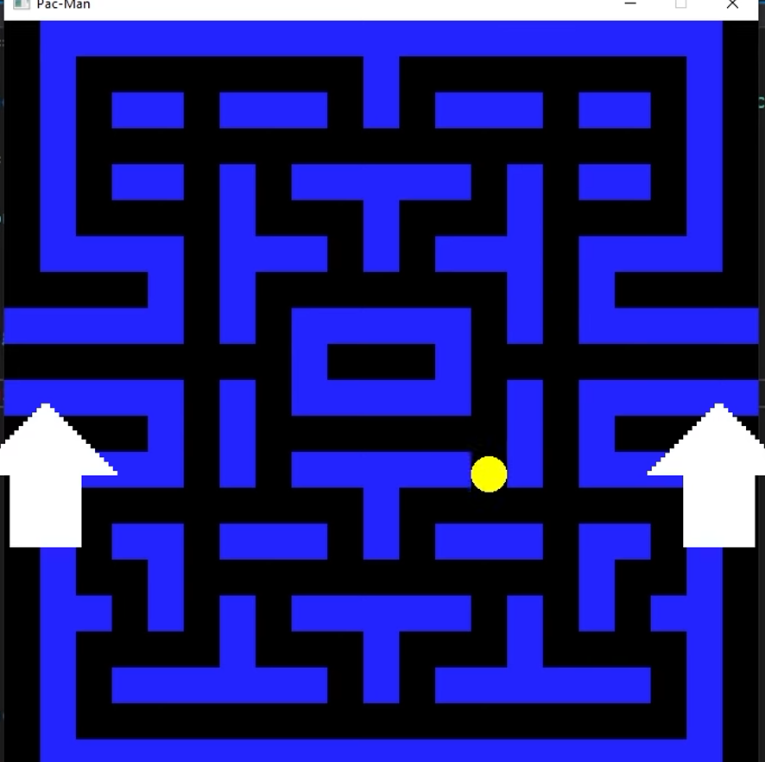

In these tunnels pacman can go in one tunnel and come out from another one in the game

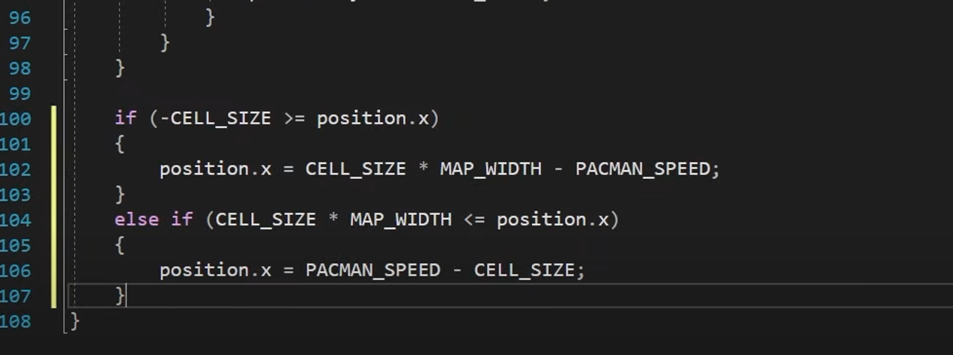

With this pacman can go through and come back

Now we will add palettes which we will add in the sketch

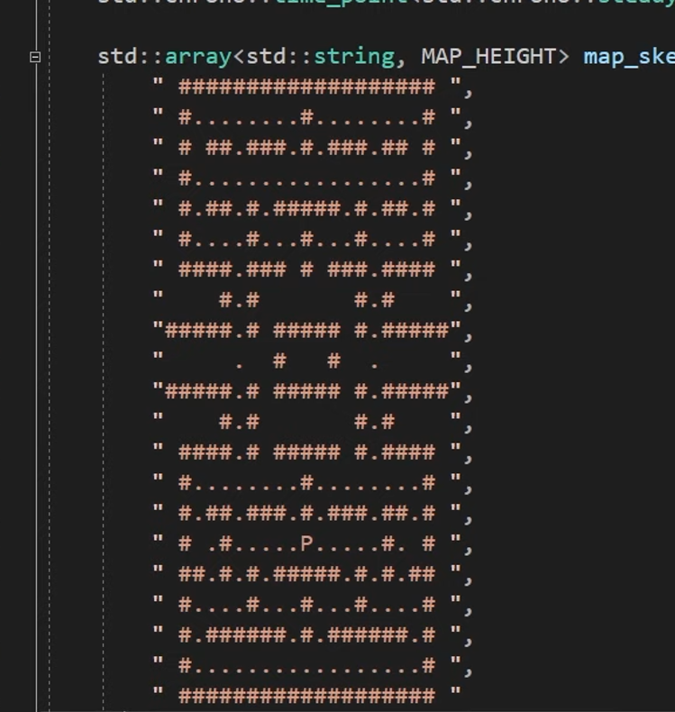

Make nice shape for these

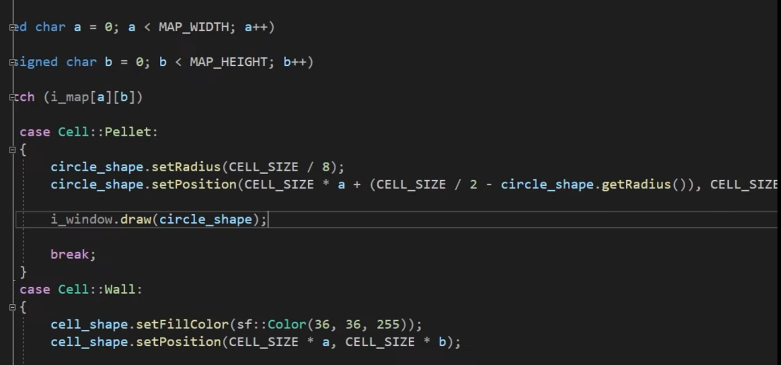

Add change some code in the Collision section that when pacman touches palettes they disappear

so the first part is complete

Now it is time for ghost

Ghosts

First we made a class for ghost

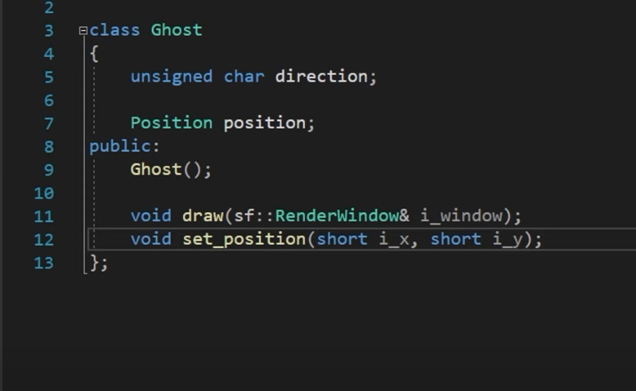

Then we make a ghost with a

 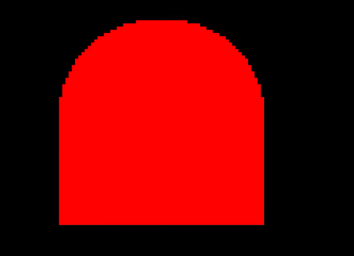

And now we did research for ghosts

**Chase**

In “Chase” mode, the ghosts are trying to find and capture Pac-Man. Each of the four ghosts has a unique behaviour while chasing Pac-Man. Blinky the red ghost is very aggressive in its approach while chasing Pac-Man and will follow Pac-Man once located. Pinky the pink ghost will attempt to ambush Pac-Man by trying to get in front of him and cut him off. Inky the cyan ghost will patrol an area and is not very predictable in this mode. Clyde the orange ghost is moving in a random fashion and seems to stay out of the way of Pac-Man.

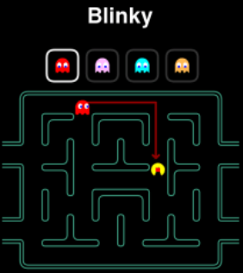 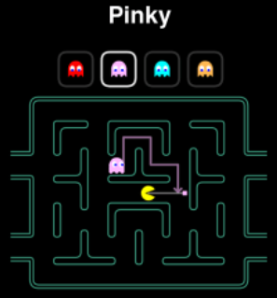 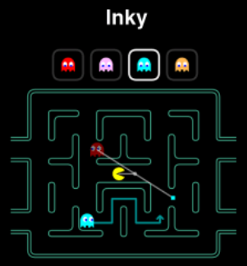

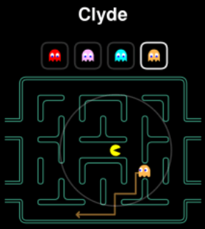

**Scatter**

In “Scatter” mode, the ghosts will stop chasing Pac-Man and each will move into its respective corners for a few seconds. Blinky the red ghost moves towards the top right corner, while Pink the pink ghost moves towards the top left corner. Inky the cyan ghost moves towards the bottom left corner and Clyde the orange ghost moves towards the bottom left corner. This mode lasts only for a few seconds and then changes back to the “Chase” mode.

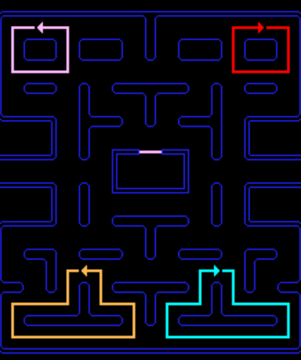**Frightened**

The “Frightened” mode occurs when Pac-Man eats an energizer within the maze. There are four energizers located in the maze and all four ghosts change mode. The ghosts turn dark blue and wander around in the maze being vulnerable. They will flash moments before they return to either the Scatter or Chase mode. So, to sum up the movement requirements of the ghosts, the following table illustrates the types of movement and also how the individual ghosts behave during those types of movement.

Ghost Name Chase Scatter Frightened Blinky (Red) Aggressive Top Right Corner Wandering Pinky (Pink) Ambush Top Left Corner Wandering Inky (Cyan) Patrol Bottom Right Corner Wandering Clyde (Orange) Random Bottom Left Corner Wandering

To implement the different ghost behaviours, the instances of the Ghost class will use the behaviour represented by an interface (ChaseBehaviour, ScatterBehaviour & FrightenedBehaviour) to ensure that the different implementations of each behaviour is not implemented within the Ghost class.

According to the Strategy Pattern, the behaviour that varies is placed into a separate class to allow you to make changes to those behaviours without affecting the parts that stays the same. Furthermore, the pattern aligns to the design principle to “Program to an Interface, and not to an Implementation” so that the three modes of a ghost can be defined as interfaces, and the different implementations of the modes of movement can be implemented in separate classes.

The Ghost class has a ChaseBehaviour, ScatterBehaviour and a FrightenedBehaviour. The HAS-A relationship refers to the composition of the classes. Now it is possible to compose the Ghost class to in such a way that each of the different types of ghosts can be composed of different implementations for each of the 3 modes of movement.

The chase behaviour of the ghosts varies, and the implementation of each of the parts are removed into a separate class. Hence, the algorithm to chase aggressively, ambush, patrol and random is placed in separate classes. An interface (ChaseBehaviour) is created to allow for the composition between the Ghost class and the different implementations of the Chase behaviour.

The following diagram illustrates the composition and implementation of the Ghost class and the different implementations of the ChaseBahaviour:

**Class Chase**

Ghost

# chaseBehaviour. ChaseBehavior

# frightenedBehaviour. FrightenedBehaviour

# scatterBehavior . ScatterBehaviour

**<<interface>>**

**ChaseBehaviour**

+ chase(): void

+chaseBehaviour

**ChaseAggresive**

+ chase(): void

**ChaseRandom**

+ chase(): void

**ChasePatrol**

+ chase(): void

**ChaseAmbush**

+ chase(): void

**Ghost**

 The Ghost class contains the different behaviour that the different ghosts have in the Pac-Man game. There are three distinct modes a ghost can be in: chase, scatter and frightened.

**ChaseBehaviour**

The ChaseBehaviour interface is used to define different ghostly behaviours during the chase mode of the Pac-Man game. In chase mode, the ghosts will have different behaviours associated with their personalities.

**ChaseAggressive**

 The ChaseAggressive class contains the behaviour of a ghost in the Pac-Man game. In chase mode, the ghost chases aggressively and will usually take the shortest route to you, and tends to follow.

**ChaseAmbush**

The ChaseAmbush class contains the behaviour of a ghost in the Pac-Man game. In chase mode, the ghost will attempt to ambush Pac-Man. The ghost tends to take a more wounding way towards Pac-Man with deadly effect.

**ChaseRandom**

The ChaseRandom class contains the behaviour of a ghost in the Pac-Man game. In chase mode, the ghost will move in a random manner around the board and is not much of a threat.

The scatter behaviour of the ghosts varies, and the implementation of each of the parts are removed into a separate class. Hence, the algorithm to scatter to the top-left, top-right, bottom-left and bottom right corners is placed in separate classes. An interface (ScatterBehaviour) is created to allow for the composition between the Ghost class and the different implementations of the Scatter behaviour.

The following diagram illustrates the composition and implementation of the Ghost class and the different implementations of the ScatterBahaviour:

**Class Scatter**

Ghost

# chaseBehaviour. ChaseBehavior

# frightenedBehaviour. FrightenedBehaviour

# scatterBehavior . ScatterBehaviour

**<<interface>>**

**ScatterBehaviour**

+ scatter(): void

+scatterBehaviour

**ScatterBottomLeftCorner**

+ scatter(): void

**ScatterTopRightCorner**

+ scatter(): void

**ScatterTopLeftCorner**

+ scatter(): void

**ScatterBottomRightCorner**

+ scatter(): void

**Ghost**

 The Ghost class contains the different behaviour that the different ghosts have in the Pac-Man game. There are three distinct modes a ghost can be in: chase, scatter and frightened.

**ScatterBehaviour**

 The ScatterBehaviour interface is used to define different ghostly behaviours during the scatter mode of the Pac-Man game. In scatter mode, the ghosts give up the chase and head for their respective home corners.

**ScatterTopLeftCorner**

 The ScatterTopLeftCorner class contains the behaviour of a ghost in the Pac-Man game. In scatter mode, the ghost will give up the chase and head for the top left corner of the board using its regular path-finding methods.

**ScatterTopRightCorner**

 The ScatterTopRightCorner class contains the behaviour of a ghost in the Pac-Man game. In scatter mode, the ghost will give up the chase and head for the top right corner of the board using its regular path-finding methods.

**ScatterBottomLeftCorner**

 The ScatterBottomLeftCorner class contains the behaviour of a ghost in the Pac-Man game. In scatter mode, the ghost will give up the chase and head for the bottom left corner of the board using its regular path-finding methods.

**ScatterBottomRightCorner**

 The ScatterBottomRightCorner class contains the behaviour of a ghost in the Pac-Man game. In scatter mode, the ghost will give up the chase and head for the bottom right corner of the board using its regular path-finding methods.

The frightened behaviour of the ghosts may does not vary, however the implementation of is still removed into a separate class. Hence, the algorithm to wander around is placed in separate class. An interface (FrightenedBehaviour) is created to allow for the composition between the Ghost class and the implementation of the Wandering behaviour.

The following diagram illustrates the composition and implementation of the Ghost class and the different implementations of the FrightenedBehaviour:

**Class Frightened**

Ghost

# chaseBehaviour. ChaseBehavior

# frightenedBehaviour. FrightenedBehaviour

# scatterBehavior . ScatterBehaviour

**<<interface>>**

**FrightenedBehaviour**

+ Frightened(): void

+FrightenedBehaviour

**FrightenedWandering**

+ Frightened(): void

**Ghost**

The Ghost class contains the different behaviour that the different ghosts have in the Pac-Man game. There are three distinct modes a ghost can be in: chase, scatter and frightened.

**FrightenedBehaviour**

The FrightenedBehaviour interface is used to define different ghostly behaviours during the frightened mode of the Pac-Man game. In frightened mode, the ghosts will all turn dark blue.

**FrightenedWandering**

The FrightenedWandering class contains the behaviour of a ghost in the Pac-Man game. In frightened mode, the ghosts will all turn dark blue and aimlessly wander around in the maze for a few seconds.

The Strategy Pattern assists with the design of the different behaviours of the ghosts in Pac-Man. Applying the Strategy Pattern to the ghost movement design, the solution become reusable, extensible, maintainable and allows for change without major impact to the rest of the code.

Now we will make a new class ghostmanager

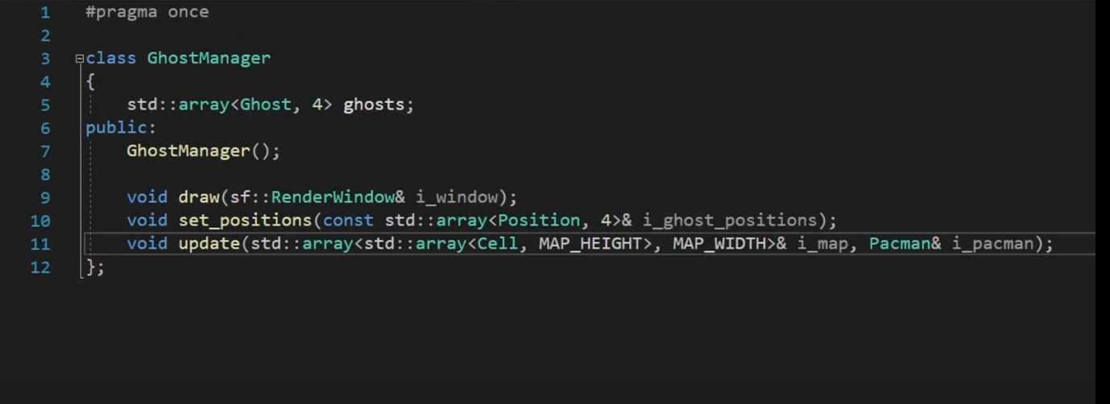

And add the behaviors and command the ghost to start there moving out of the door

Output

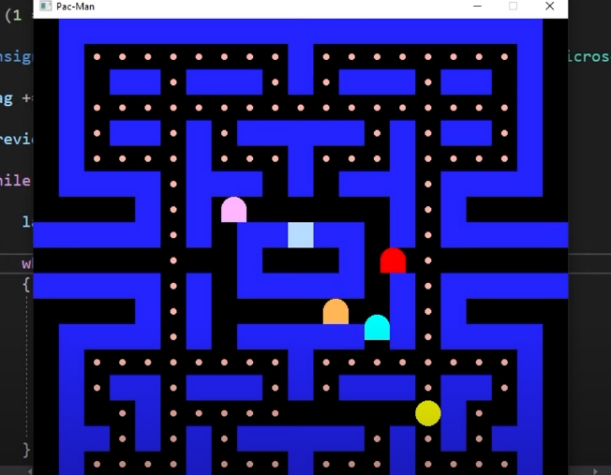

And one of the failure output

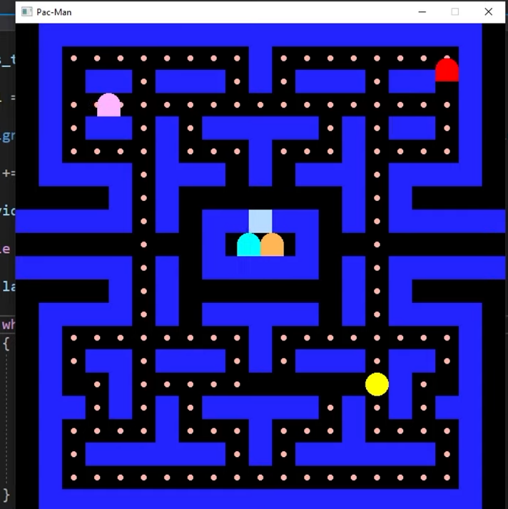

Now the second part is over

Game play

Now we will add wave attacks

First we set the timer

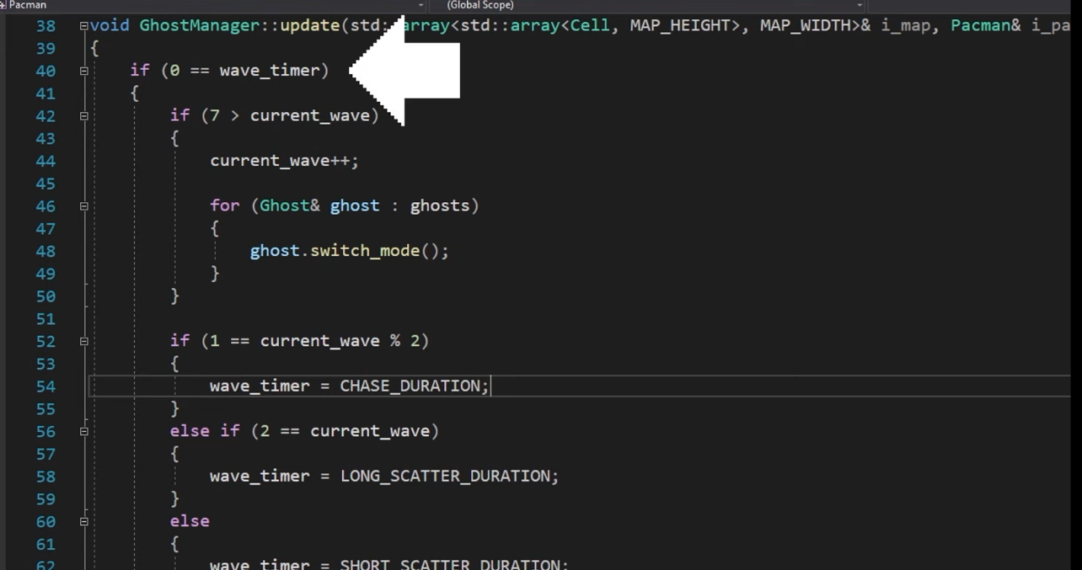

Second is to set switch mode that switch between chase and scatter

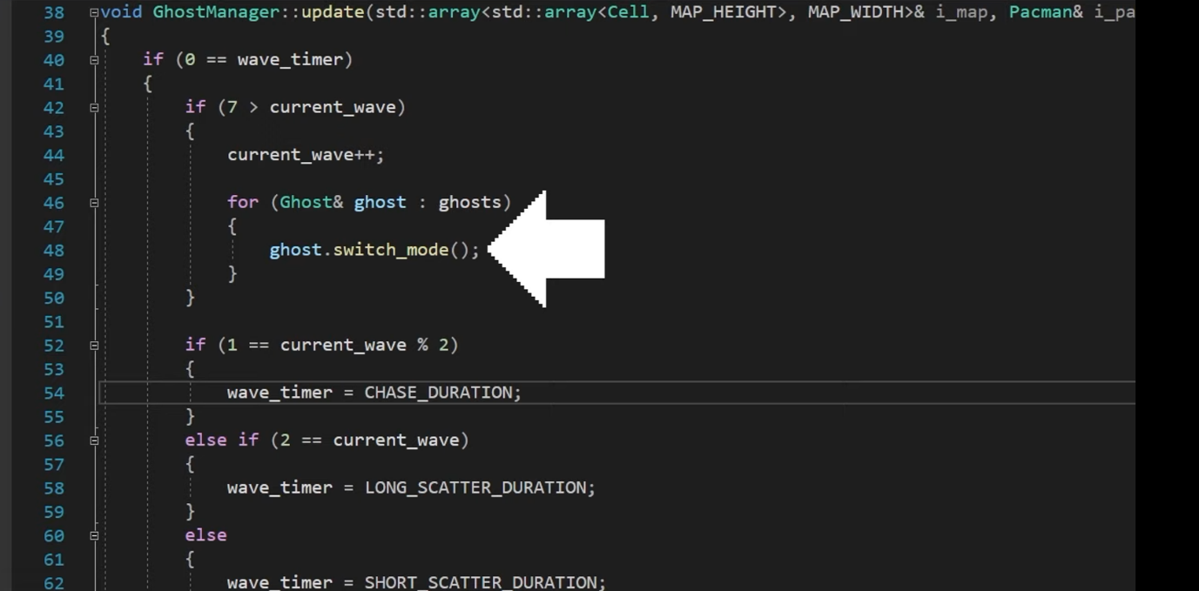

And the last is to restart the timer

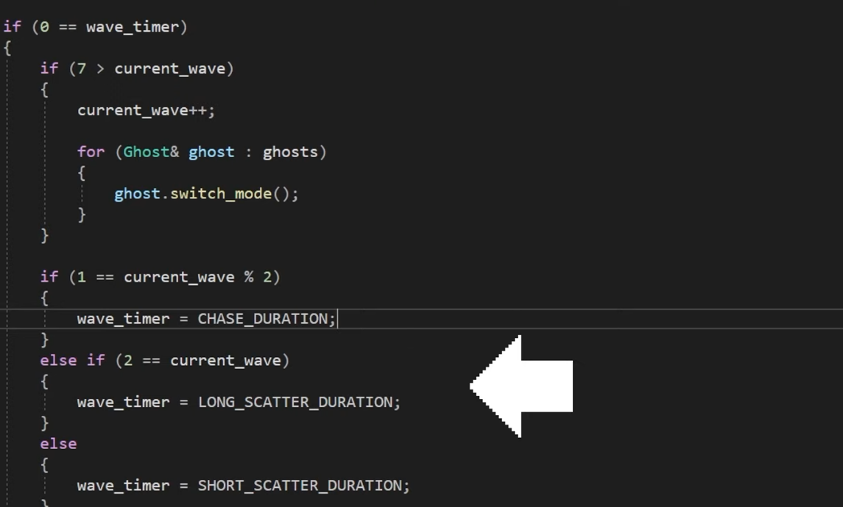

The output was that first the ghosts will shatter and then chase pacman

In the start I showed you the map and there were four empty places In the map we were suppose to put energizers in that place

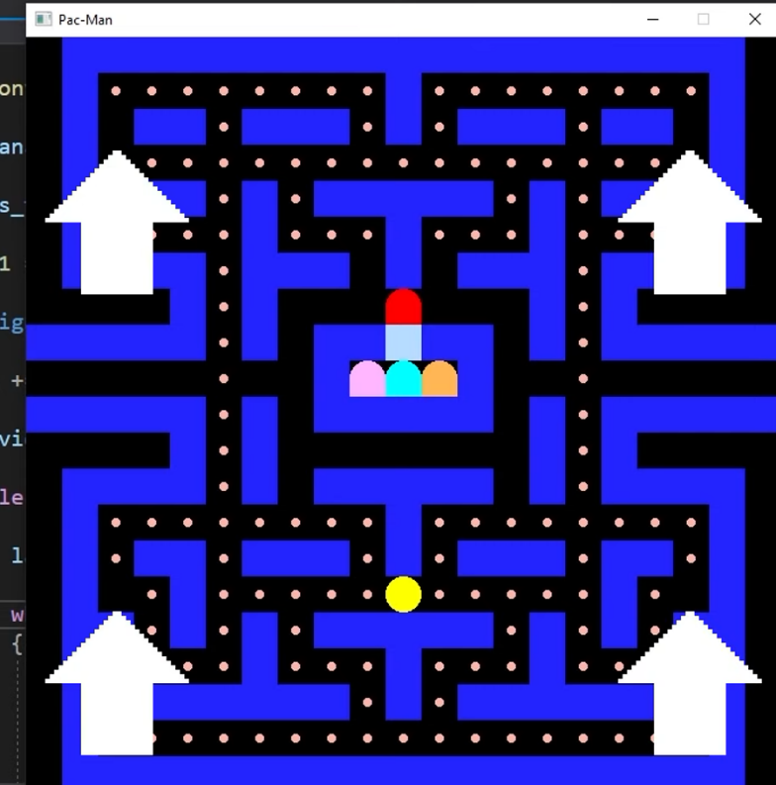

Now we put it in the sketch

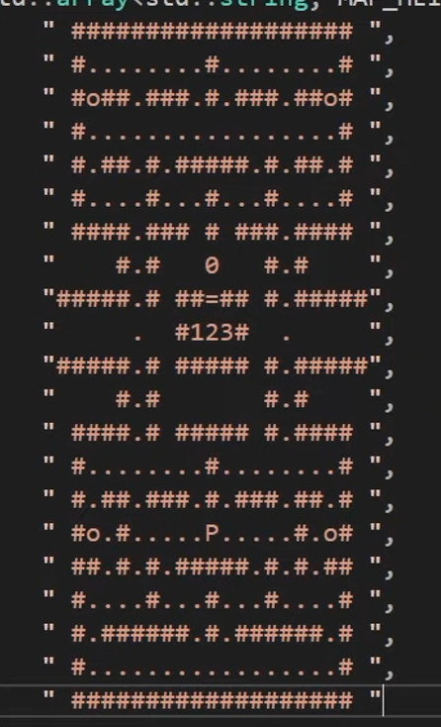

And make it edible for pacman

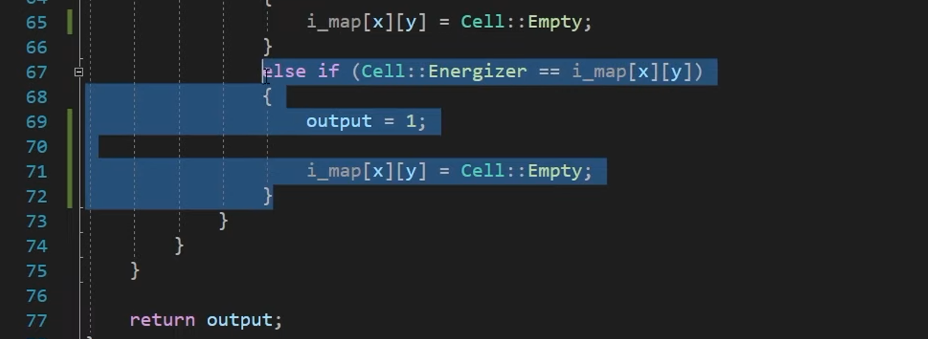

And add timer and frightened mode

In this time ghost will become slow and pacman will be able to eat the ghost and when the ghost are eaten it will return home and will not be in frightened mode anymore

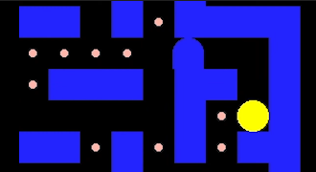 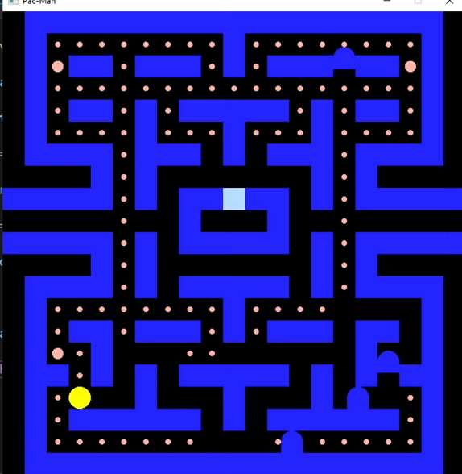

Now we add win and lose

First we will added match ending

We add a function if pacman collided with the ghost

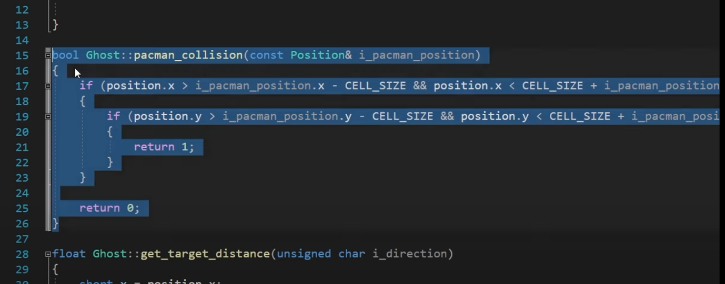

After that we added another function that if pacman collides with the ghost it will only display pacman and remove everything from the screen

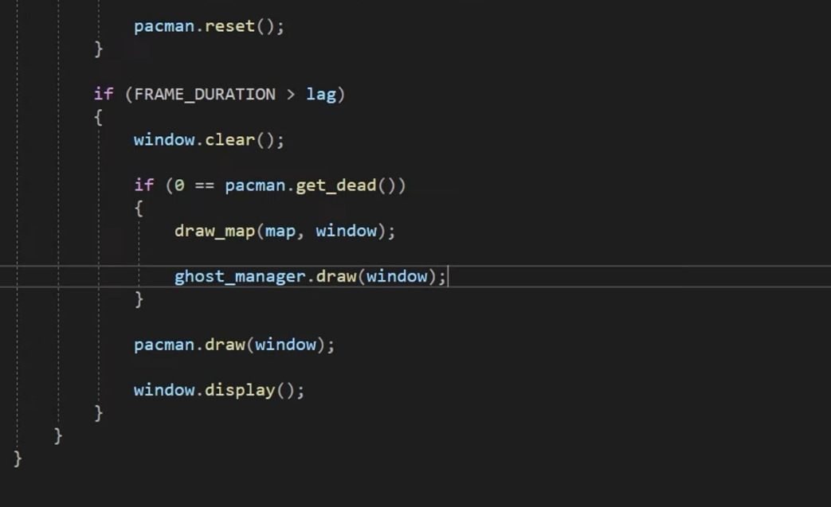

Output

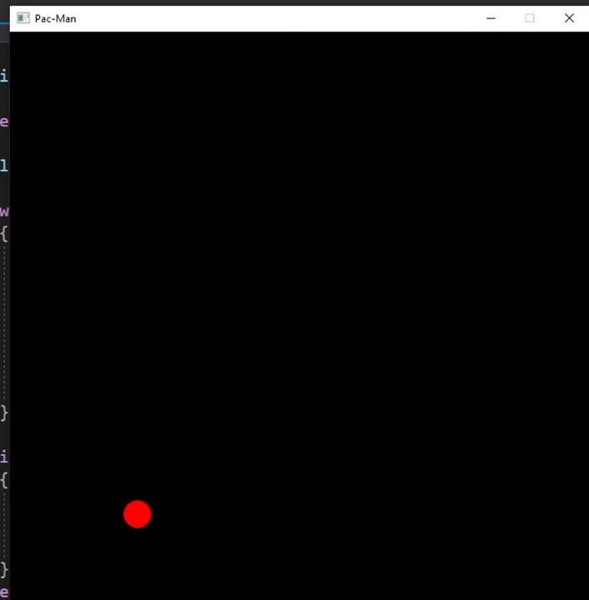

After this we add winning condition

We check if the pallets left in the map

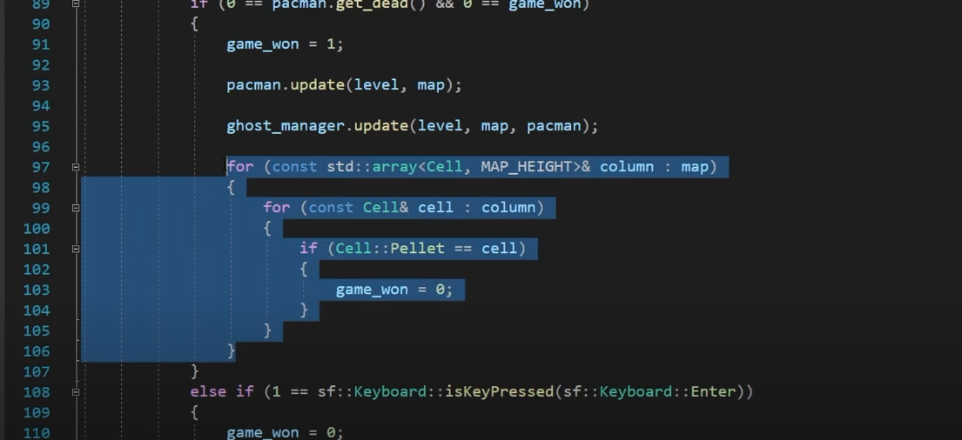

And display a different screen if the game is over

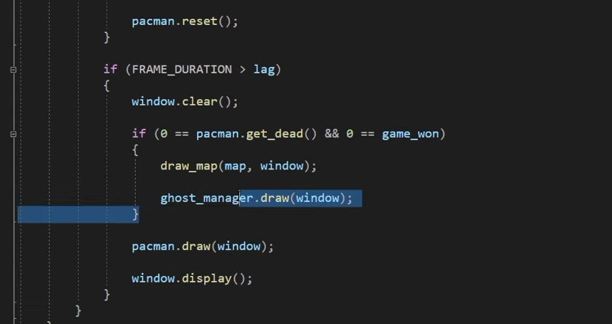

And after that increase the difficulty

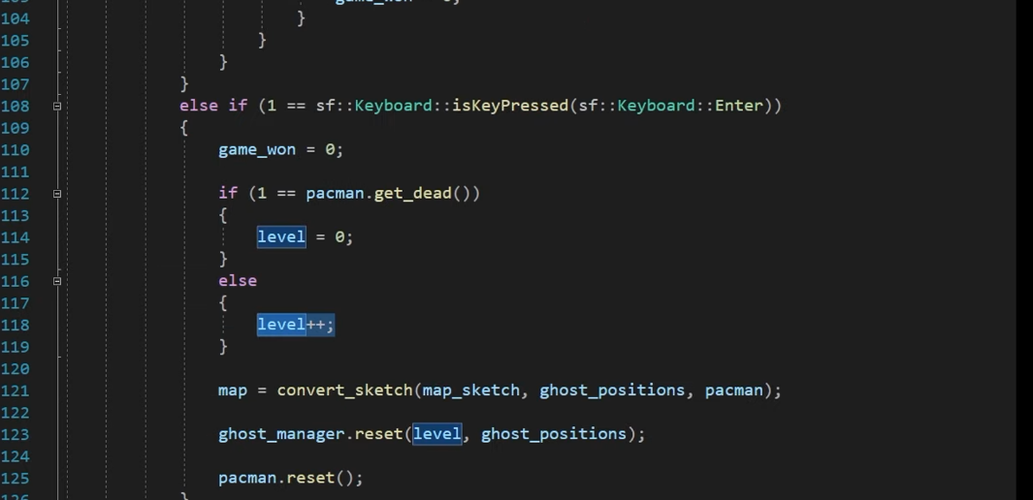

And after this game is been complete and after this we just made the game pretty